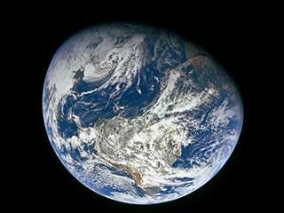

NWSOFA Climate Change Special Presentation

May 26, 2020

7:00-9:00

Virtual Meeting via Webex

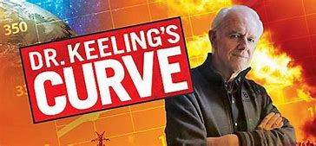

"Dr. Keeling’s **Curve**" by playwright George Shea, is a one-man show performed by actor Mike Farrell, star of the TV show MASH. Farrell plays scientist Dr. David Keeling, whose research on atmospheric carbon dioxide levels led to the iconic chart now known as the Keeling Curve.

In 1958, Charles David Keeling began making daily measurements of the concentration of atmospheric carbon dioxide (CO 2) at the Mauna Loa Observatory on the Big Island of Hawaii. These measurements were begun as part of a one-year initiative, the International Geophysical Year, but because of Keeling's persistence, the daily record has continued through the present, almost without interruption. The Mauna Loa record, now known as the [Keeling Curve](http://earthguide.ucsd.edu/globalchange/keeling_curve/01.html" \t "_blank), continues to be collected under the direction of Keeling's son, [Ralph](http://scrippsco2.ucsd.edu/personnel/ralph_keeling.html" \t "_blank).

Trailer for the movie

<https://www.bing.com/videos/search?q=keeling+curve+video&&view=detail&mid=7ABCCF689FF2B2061E9A7ABCCF689FF2B2061E9A&&FORM=VRDGAR>

Join us for an enlightening evening!

**RSVP-http://act.indivisible.org/event/attend-local-actions/153007/?source=taf&aktmid=tm800458.5T\_0o\_&t=1&referring\_akid=.1184745.3wWg-d**